Project Phase 3 to do

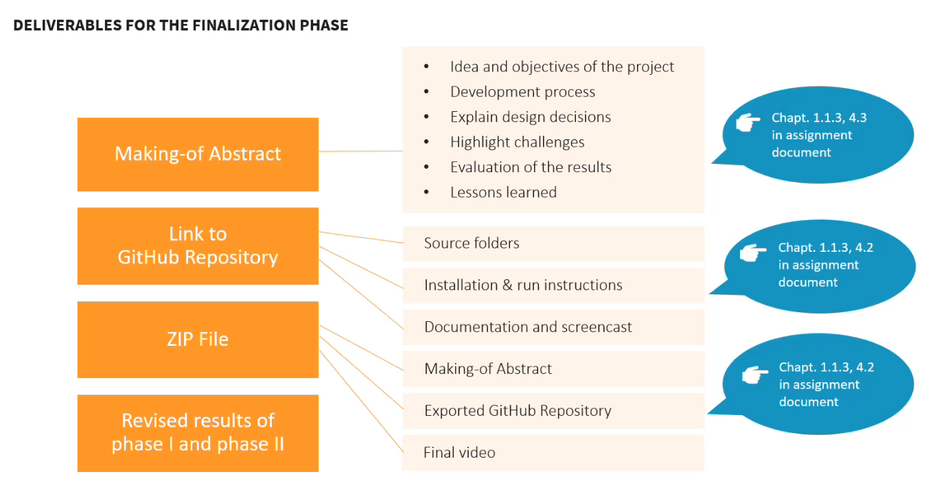

Making of abstract
Teacher | Document
- What is technology?  - How did I use it to create a web app  - What did I do  - What steps  - How did I implement  - How did I use it  - Personal lessons learned  - What was helpful for me  - Key takeaways | - Idea and objectives of the project  - Development process  - Explain design decisions  - Highlight challenges  - Evaluation of the results  - Lessons learned

